European Certificate in Intergenerational Learning
(ECIL) – Newsletter No.6

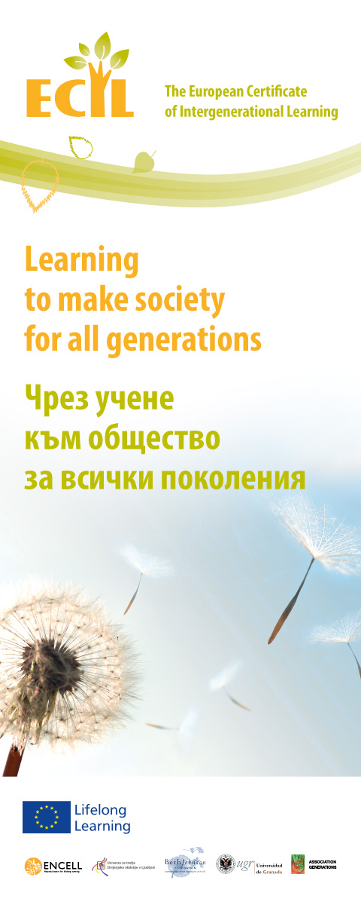

The project is financed by the European Commission programme Leonardo da Vinci, Transfer of innovations, Nr 2012-1-GB2-LEO05-08174

Intergenerational News & Events

We are pleased to invite you to the Conference "Learning to make society for all generations" – a final event of project ECIL - The Development of a European Certificate in Intergenerational Learning – LLL, LdV, ToI, Nr 2012-1-GB2-LEO05-08174 which will take place on 18 September 2014 in Sofia, at the Best Western City Plus Hotel. The conference will bring together EU and national representatives from business, civil society, public authorities, charitable organisations and educational organizations to discuss some of the new challenges caused by the demographic situation in Europe and methods for overcoming problems between people from different generations using new training approaches.

During the conference, the main results of 2 years work of the ECIL project consortium will be presented – a new distance learning platform and course for IG learning. In addition, educational experts and EMIL Award recipients from different European countries will showcase examples of good practice in the field of intergenerational learning.

Through your participation, you can help to start the implementation of IG training/learning method in vocational and adult education - bringing positive impact and better efficiency in community and business world.

For more information, please contact us via e-mail:

ecileu@abv.bg

1
European Certificate in Intergenerational Learning
(ECIL) – Newsletter No.6

Intergenerational Communication
in an Ageing World

COMUNICAR a bilingual (Spanish-English) open access online journal devoted to look at communication, technology and media education is planning to publish a whole thematic issue on challenges and opportunities linked to communicating in an ageing world. In the call for papers guest editors explain that this issue approaches ageing not only as related to elderly persons, because as we move through life, we are all ageing, and we interact with one another from our particular generational position. Therefore, issues regarding Information and Communication Technology challenges and possibilities for multi- and inter-generational communication and cooperation are relevant to this special issue.

Submission of manuscripts for this thematic issue is open till 30th October 2014. More information is available through this link.

Learning in Later Life-Intergenerational Learning: Working towards the Professionalization of professional workers and volunteer staff working with older and younger learners

For organizations working with older and younger learners - Cyprus, 22-27 OCTOBER 2014, AND 18-23 FEBRUARY 2015

Cyprus Adult Education Association is pioneer in organizing successfully seminars and in service training courses for the last 10 years. The last 5 years the focus was on Learning in Later life-Intergenerational cooperation where more than 160 participants from 28 European countries took part.
The training course will build on the experience of the delegates attending to help us all to become better teachers, facilitators and managers. The team of trainers will encourage and stimulate participants to reflect on their own experiences, learn from colleagues and return home with fresh contacts and renew confidence and competence.

CONTACT INFORMATION
Course manager: Klitos Symeonides
Email: klitossy@cytanet.com.cy

Website: www.euroculture.com.cy

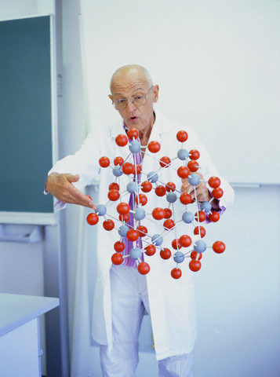

2

1
1
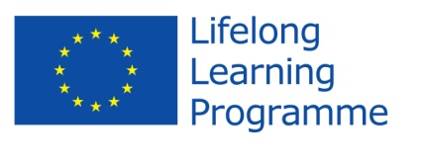
The project is financed by the European Commission programme Leonardo da Vinci, Transfer of innovations, Nr 2012-1-GB2-LEO05-08174
2
European Certificate in Intergenerational Learning
(ECIL) – Newsletter No.6

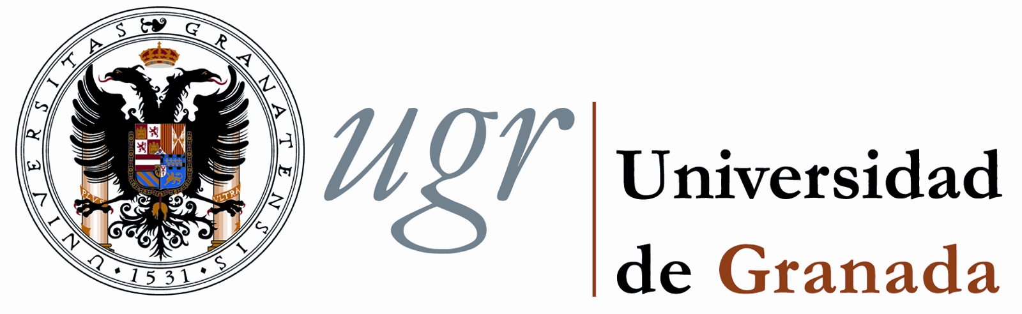

www.ugr.es

Message from Spain

After extensive improvement of our initial version of ECIL training materials, the second Spanish pilot to validate the three online learning units integrating the European Certificate in Intergenerational Learning started on the 6th of May. Thanks to the strong commitment by the Centre for Teachers (run by the Andalusian Government) in Granada, we were able to gather an initial group of 16 people willing to collaborate in this process. The profile of the group was very diverse: 2 master students, 2 certified experts in intergenerational work, 1 psychologist, 2 social projects managers, and, what’s more important, 9 Vocational Education and Training (VET) teachers. After an introductory face-to-face session, participants in the pilot started to work on the ECIL platform. Three more intergenerational practitioners based in Madrid, Extremadura, and Valencia joined the main group. By the 12th of June the majority of these people had completed the training fully.

Much beyond the original intention to involve 10 people in this pilot, fruitful collaboration with the Faculty of Social Work within the University of Granada made it possible that 5 undergraduate Social Work students were accepted as well to take part in this process. Finally, one of our VET teachers, affiliated to Alhadra High School decided to go one step forward: she is currently tutoring 8 VET students enrolled in the VET Higher Cycle on Early Childhood Education. Involving both real higher education and VET students and not just their teachers will allow us to gain feedback straight from our most envisioned type of learners to benefit from the Certificate in Spain.

Overall, and according to data gathered throughout this experience, participants in the pilot find the ECIL learning platform quite useful and easy to use. Furthermore, their general feedback about the actual content indicates that the main concepts have been grasped quite well. However, thanks to this second pilot a full list with recommendations for change(s) regarding both the platform structure and its content has been compiled. At present we are introducing suggested changes so that the final online training package can be enhanced before its official launching by the end of September 2014.

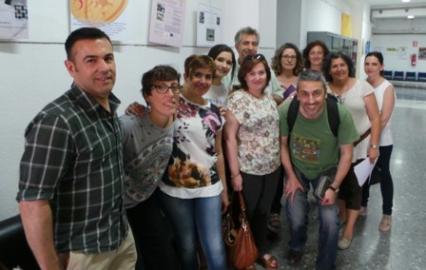

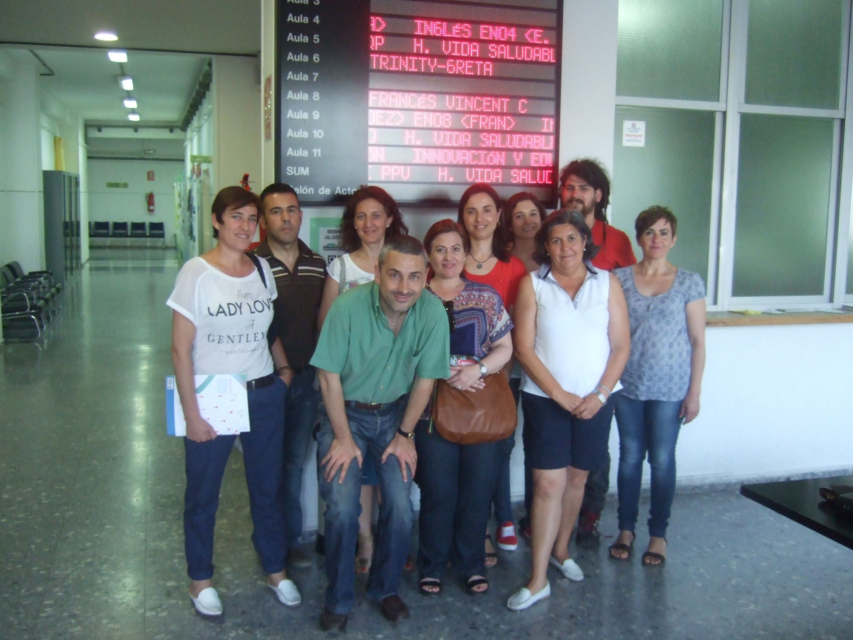
3

4
4
4
4
3
European Certificate in Intergenerational Learning
(ECIL) – Newsletter No.6

www.univerza3.si

Message from Slovenia

DANET is against brain drain and for intergenerational dialogue

Slovenian Third Age University has become a founding member of DANET, a new European association for older people’s learning, participation and intergenerational dialogue in Europe and particularly in the Danube basin.

Naturally, on several occasions, the most recent being the Danube Festival in July, ECIL was presented and discussed. All who were present agreed that intergenerational co-operation and learning as well as programmes supporting them, are badly needed since the countries of the Danube basin have been experiencing ‘brain drain’. The situation is due not only to economic reasons, but also to the fact that in a knowledge based society people move to regions with more cognitive resources. Therefore intergenerational learning and co-operation are needed (i.e. the kind of learning that would help younger people stay in the country where they were educated) through creating new and interesting jobs. It was suggested that old skills along the Danube should be identified and that excellent designers should be united with craftsmen and younger people, creating new products.

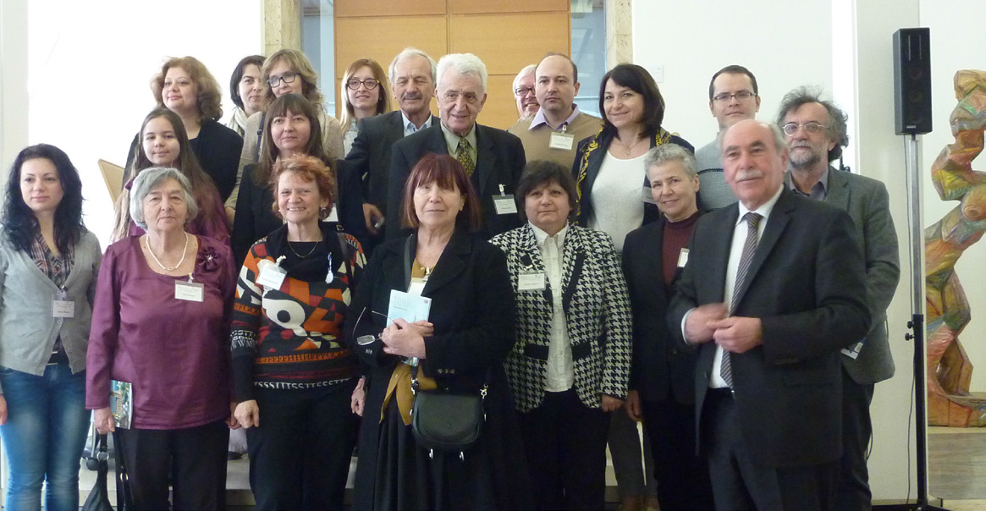

To sum up, structures for intergenerational learning and education are needed in order to re-establish intergenerational ties and intergenerational communities. Namely, throughout history - relating to others, belonging to community of all generations has been a way to get protection against hardships and to get recognition from the others, to shape one’s identity and to learn from each other.



www.generations-bg.eu

Message from Bulgaria
2-и пилотен тренингкт ECI стартиране нтформата за дистанционно
After development of the e-course for implementing intergenerational methods in adult education and vocational training and much effort invested in creating a platform for distance learning, the second pilot workshop within the project ECIL was held in May & June, 2014. The aim was to test the technical operation of the platform and get feedback from the participants about the appropriateness and quality of the course. The seminar was attended by some of the participants in the first pilot workshop which took place in summer 2013.

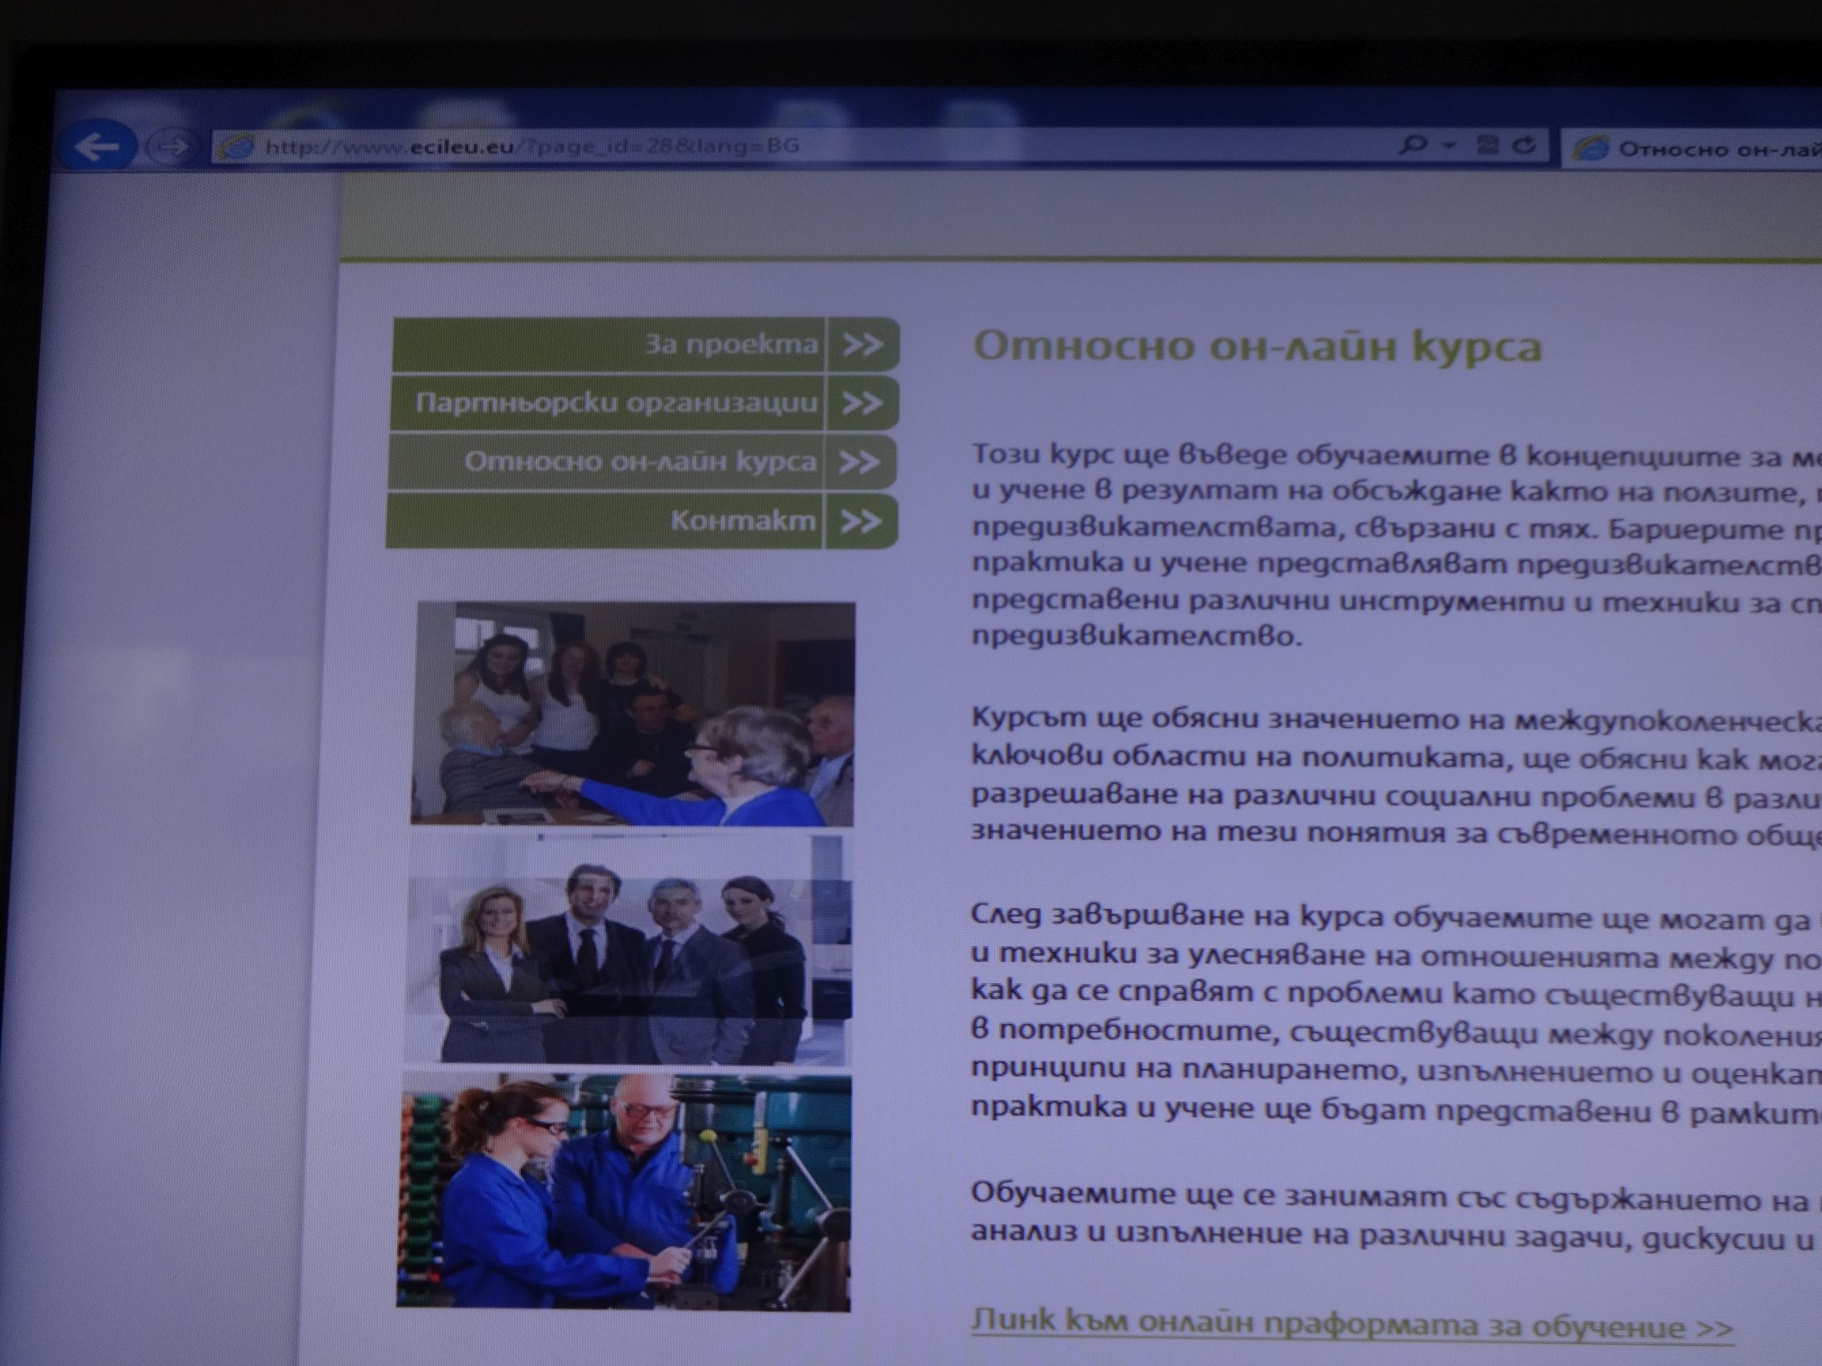

The start of working with an e-learning platform was successful and was met with interest by all. But we still have a lot to do until it is ready, especially to continue enrichment and expansion. The electronic platform is multilingual - each partner organization in the project included in the section of its language, not only the main course, but many different learning materials - videos, books, publications, links to other websites with relevant content to intergenerational topics.

Responsible for compiling of the ECIL newsletter –
Association Generations, Sofia
www.generations-bg.eu

4
4

